Project Design Phase Solution Architecture

Date | 15 February 2025
Team ID
Project Name | Importing & Securing Data in ServiceNow (Import Data using Transform Maps)  6ab6292ddcdae33acb3906da
Maximum Marks | 4 Marks

Solution Architecture:
Solution architecture is a complex process – with many sub-processes – that bridges the gap between business problems and technology solutions. Its goals are to:
- Find the best tech solution to solve existing business problems.
- Describe the structure, characteristics, behavior, and other aspects of the software to project stakeholders.
- Define features, development phases, and solution requirements.
- Provide specifications according to which the solution is defined, managed, and delivered.

Business Problem and Solution
Problem: Training records kept in spreadsheets are not linked to employees, and employee details such as department are not available in the record for reporting.
Solution: Employee training data is loaded from a spreadsheet (.xlsx) into ServiceNow through an Import Set, mapped to a custom table with a Transform Map, linked to the sys_user table through a Reference field, enriched with the employee's department by dot-walking, and secured with role-based Access Control Rules (ACLs).

Solution Architecture Diagram:

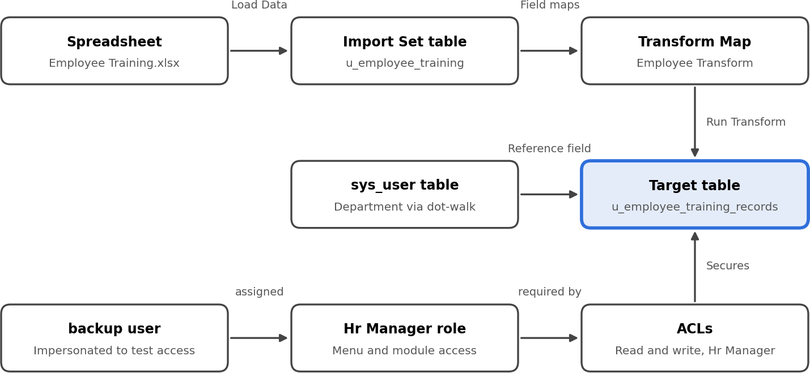

Figure 1: Architecture and data flow of importing spreadsheet data into ServiceNow using a Transform Map

Components and Data Flow

Step | Component | Purpose
1 | Spreadsheet (Employee Training.xlsx) | Source file with Training Name, Completion Date, Status and Employee.
2 | Load Data (System Import Sets) | Uploads the file and creates the staging table u_employee_training.
3 | Import Set table | Holds the raw imported rows before they are transformed.
4 | Transform Map (Employee Transform) | Maps source fields to target fields and runs the import.
5 | Target table u_employee_training_records | Stores Training Name, Completion Date, Status (Choice) and Employee (Reference to sys_user).
6 | sys_user table | Supplies employee details; Department is shown on the record by dot-walking (Employee.Department).
7 | Roles, ACLs and Impersonate User | Role Hr Manager is given read and write ACLs on the table; the setup is tested by impersonating users.

Security and Testing
- A user (backup user) is created and assigned the Hr Manager role.
- The role is added to the Employee Training Records application menu and module.
- Read and write ACLs on u_employee_training_records require the Hr Manager role.
- Impersonating the Hr Manager user shows and allows editing of the records; impersonating any other user hides the table.
Reference: Smart Internz / SmartBridge project guide – Importing & Securing Data in ServiceNow

